**RaspberryPi Configuration**

1. First you will need to download Raspberry Pi OS (previously called Raspbian) with desktop and recommended software:

<https://www.raspberrypi.org/downloads/raspberry-pi-os/>

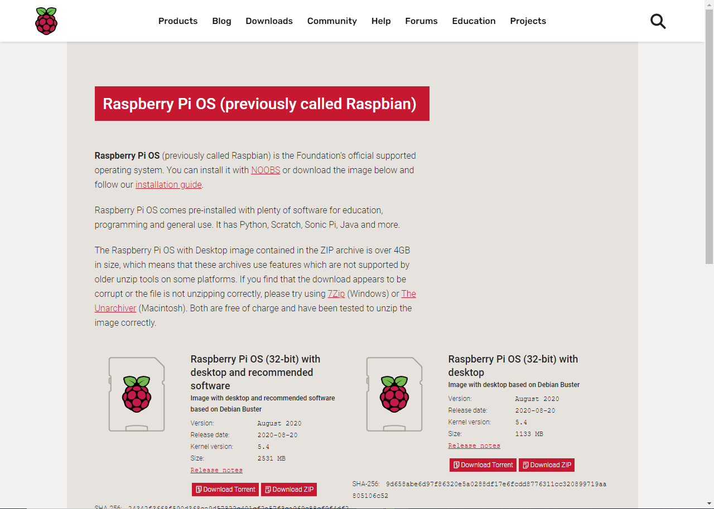

1. After downloading you will need Etcher to burn the iso that you downloaded to your SD Card:

<https://www.balena.io/etcher/>

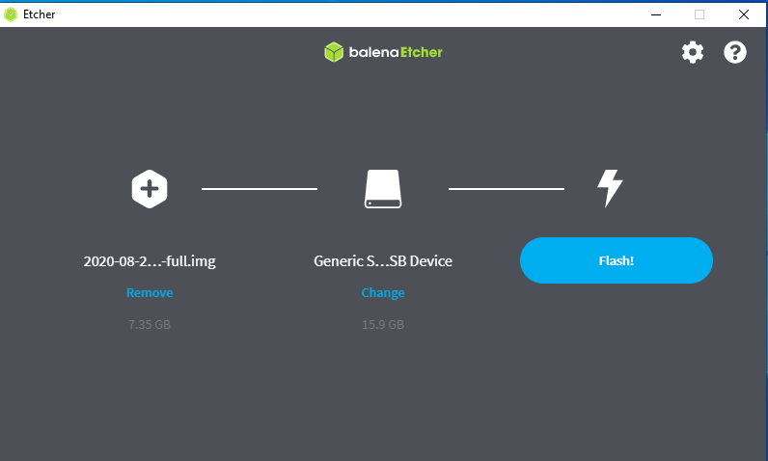

1. Then chose the image and the target (your SD card) then press Flash and wait until its done: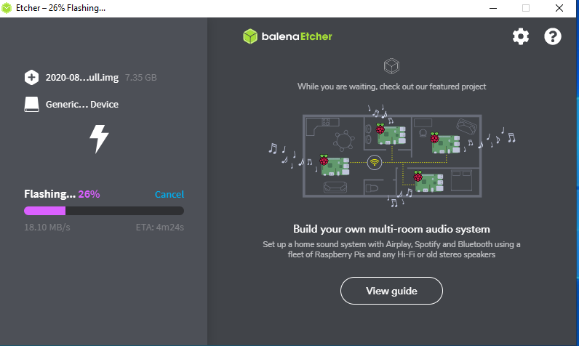
2. While Etcher is burning, download PuTTY to control your RaspberryPi via SSH protocol:

<https://www.putty.org/>

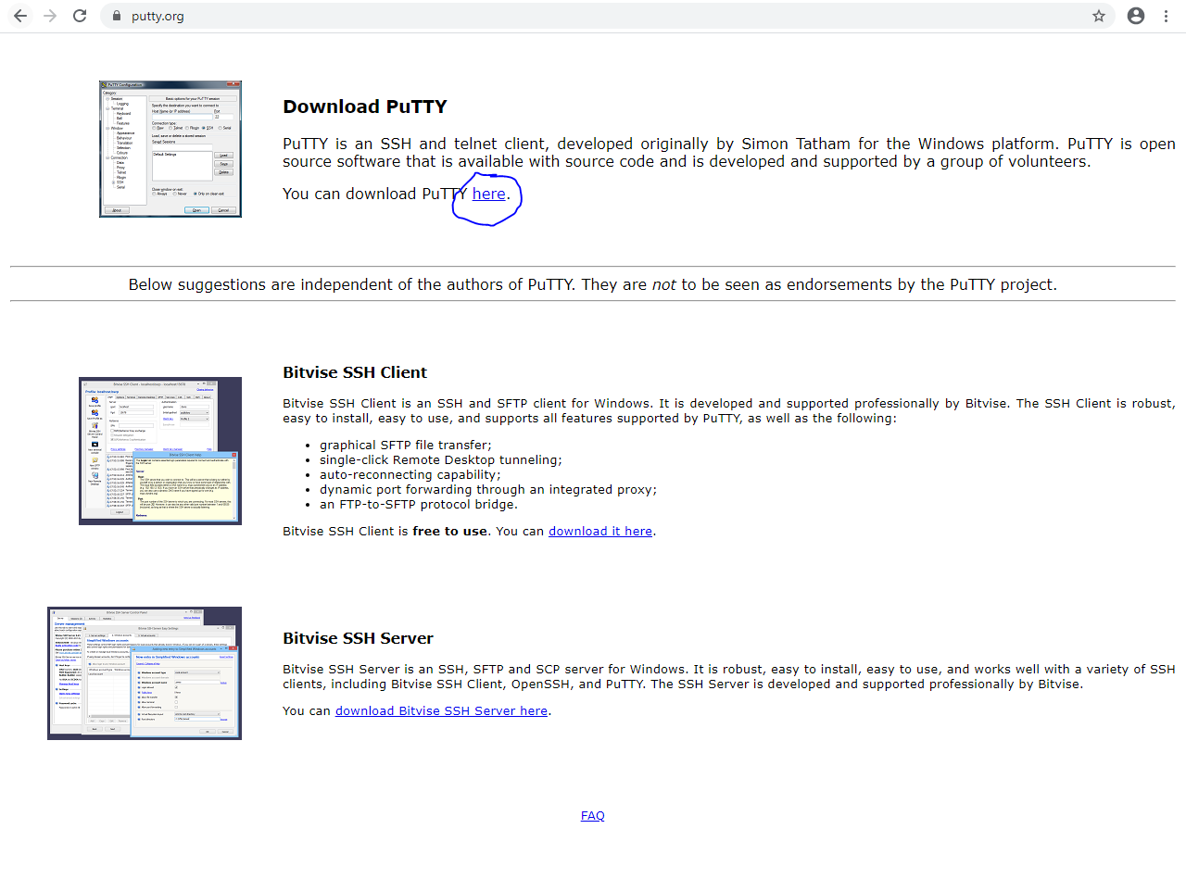

1. Install PuTTY by pressing next until its installed:

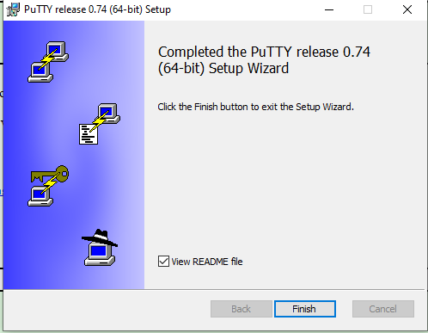

1. After that you will need to these 2 files:

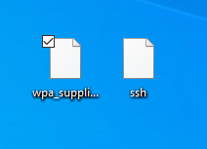

1. Download these files here:

<https://drive.google.com/file/d/1GWqfWKrRTRP22C_o3jK6Q79_ySPk2OMB/view?usp=sharing>

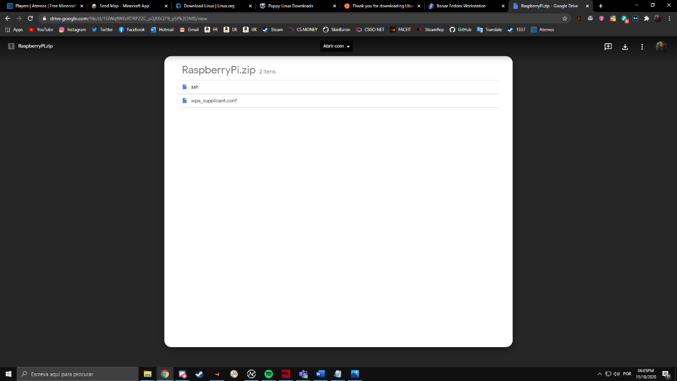

1. 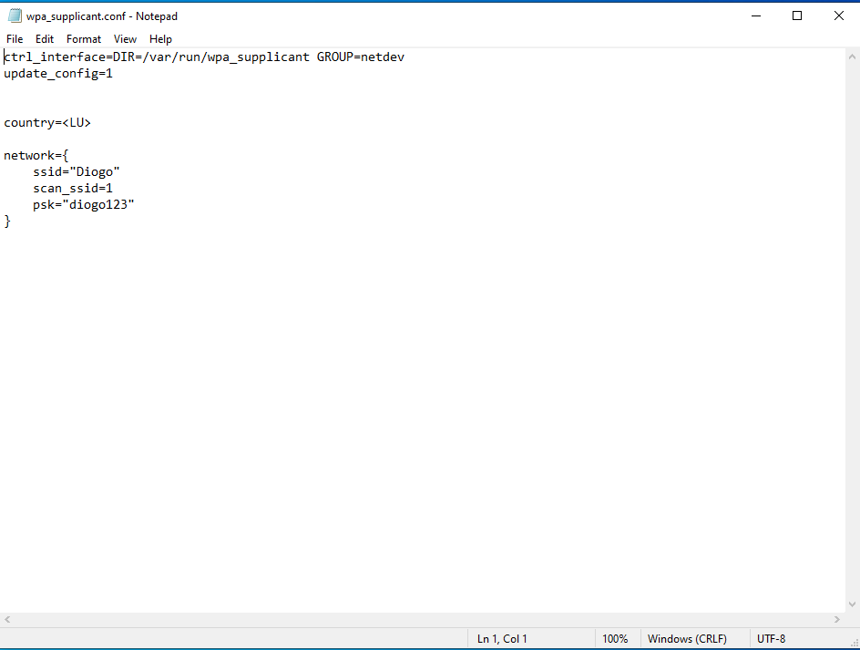Then change the “wpa_supplicant.conf” with Notepad and put your information like this:
2. Then put the 2 files inside the SD Card that its now called Boot:

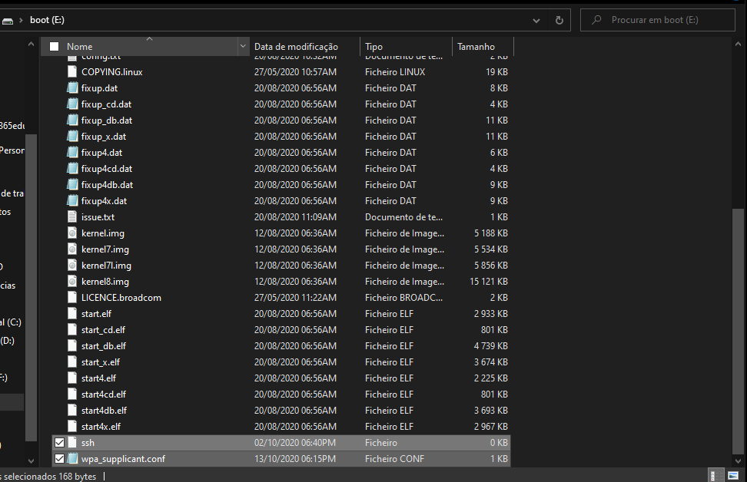

1. Then just remove the SD Card from the USB Reader and put on Raspberry and turn on. 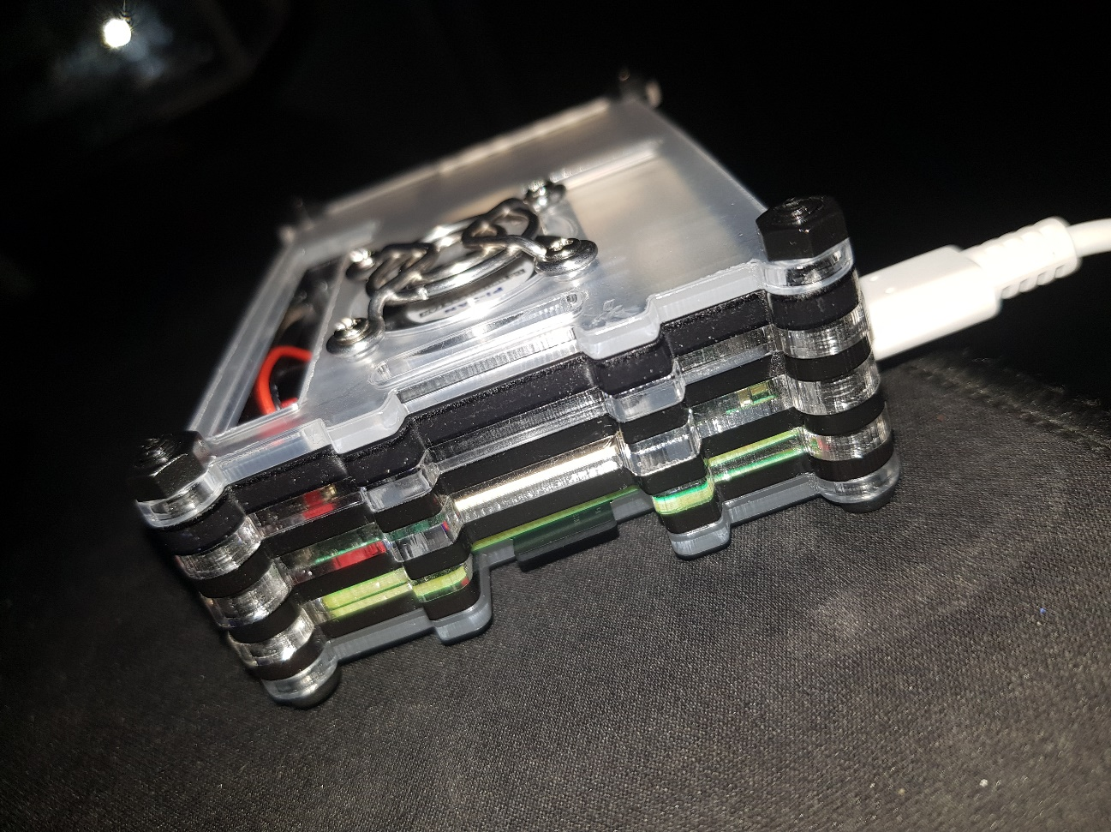
2. Now go to your router web interface by going on <http://fritz.box/> or just go in CMD and type “ipconfig” and copy paste your Default Gateway in browser then login:

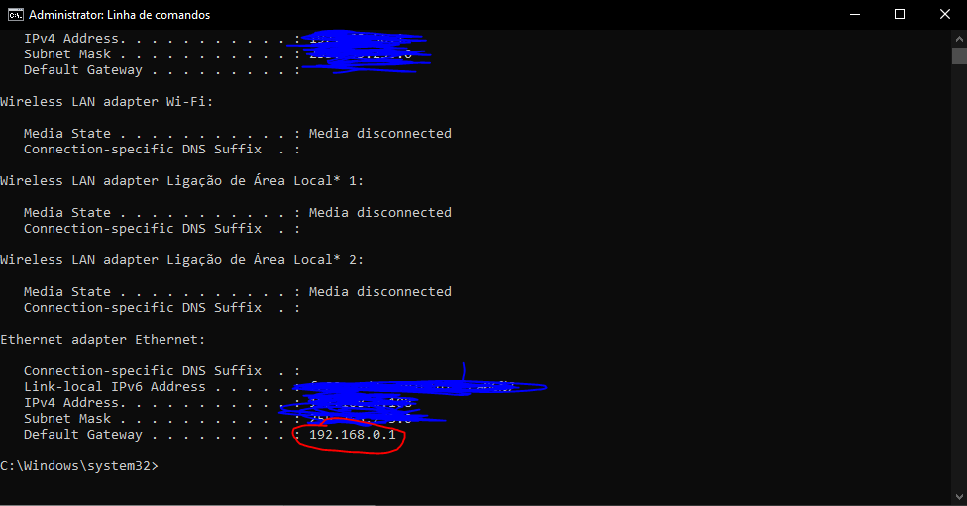

1. After that you should go to your devices connected to your router and see what is the ip address of your Raspberry:

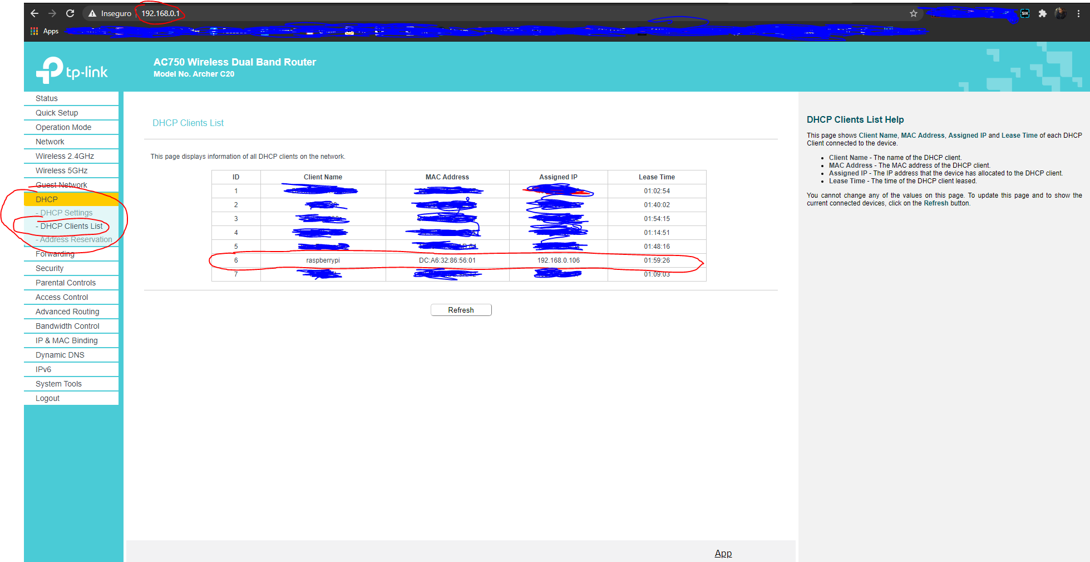

1. Now copy the ip address of your raspberry and open PuTTY and past there:

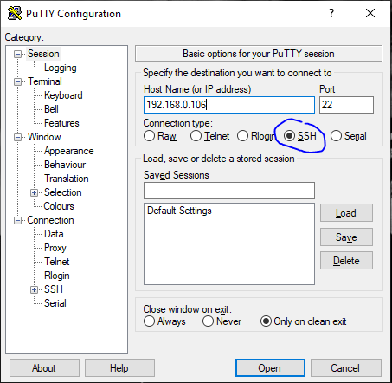

1. Then click Open and then it will appear a new window and you just click yes:

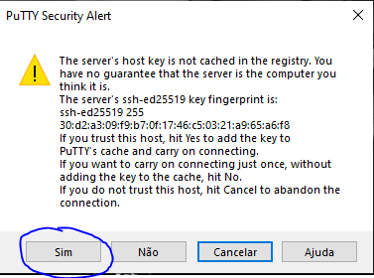

1. The login with “pi” and password “raspberry” (without quotes “”):

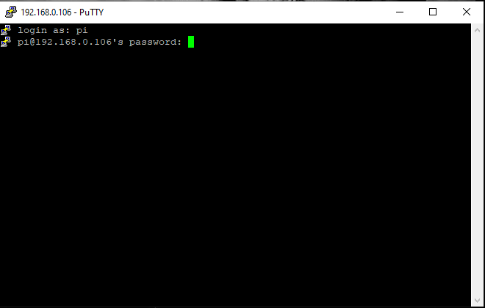

1. After you login write “sudo raspi-config” (without quotes “”) and wait until one window opens:

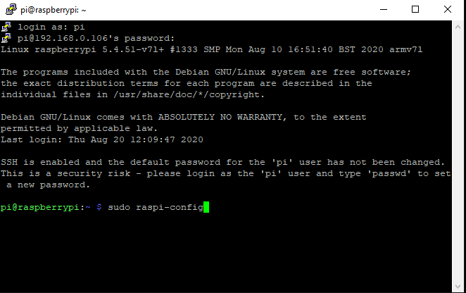

1. Then choose the first one and press enter to change user password:

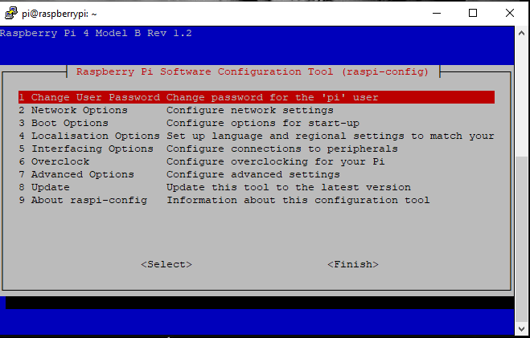

1. After changing it will appear this window:

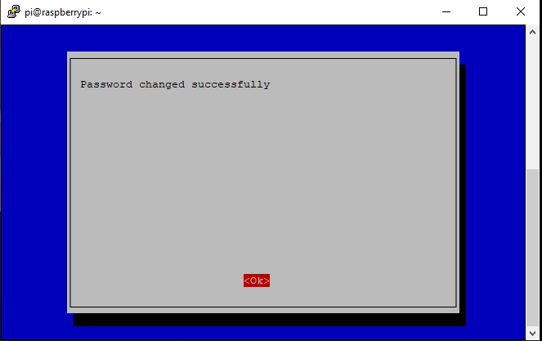

19.Then you will be back to the same window as before and now you choose the second one to change the hostname and press enter:

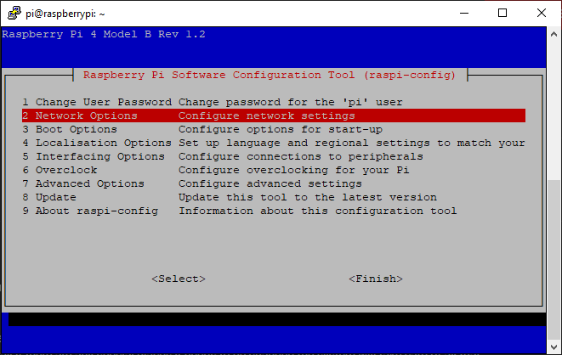

20.The choose the “N1 HostName” and press enter:

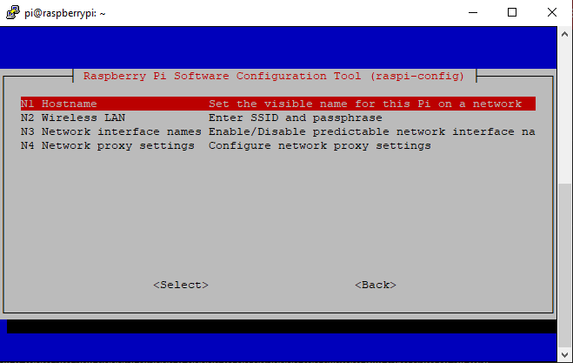

21. Then erase the previous hostname and write anything you want but you need to pay attention to the characters allowed:

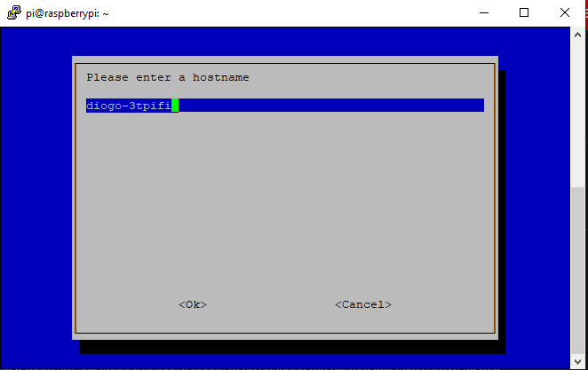

And as you see in my router web interface it’s the name that I chose:

22. Then you will be back to the same window as before and now you choose the fifth one to activate the VNC protocol and press enter:

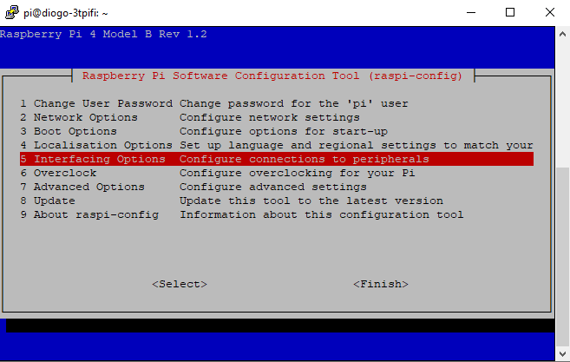

23. Then choose VNC and enable it:

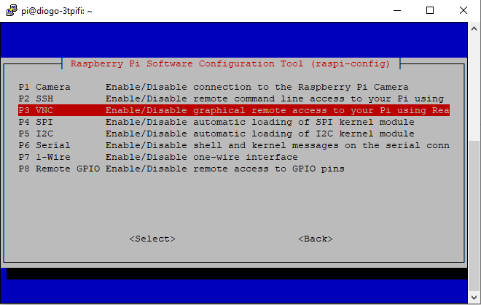

24. Then you will be back to the same window as before and now you choose the seventh one to change the resolution and press enter: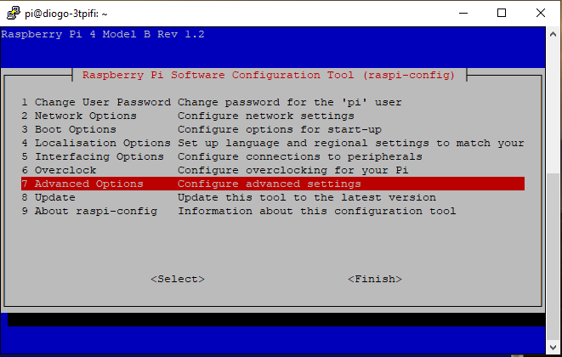

25. Then choose “A5 Resolution” and press enter:

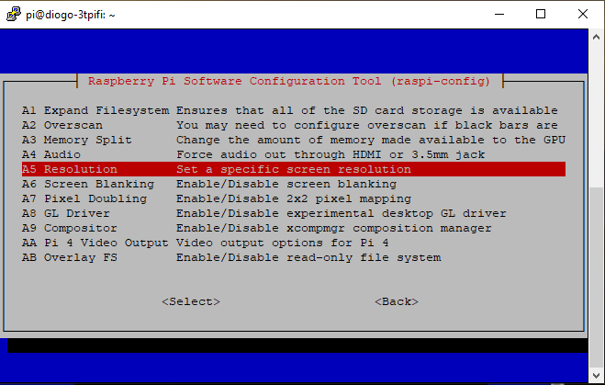

26. Then choose “DMT Mode 85 1280x720 60Hz 16:9” or “DMT Mode 82 1920x1080 60Hz 16:9” (I recommend the last one 1920x1080) and press enter:

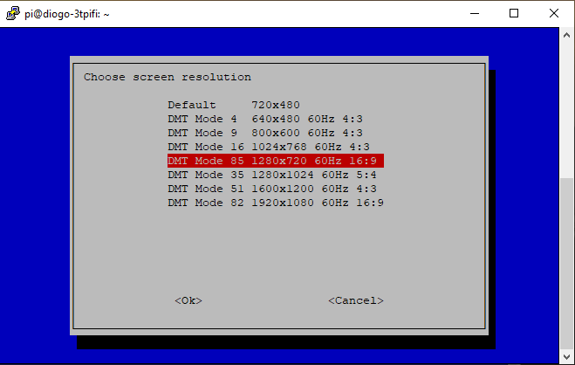

27. Then you will be back to the same window as before and you click in finish and you click on yes to Reboot your RaspberryPi:

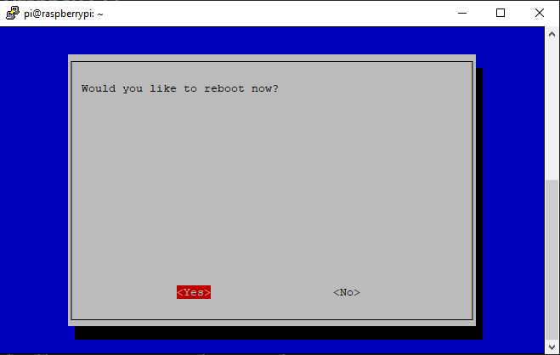

28. After you rebooted your RaspberryPi you will change your ip to a static one with theses commands, first write “ifconfig” (without quotes “”) to check your RaspberryPi ip address but pay attention if you are using ethernet (eth0) cable or Wi-Fi (wlan0):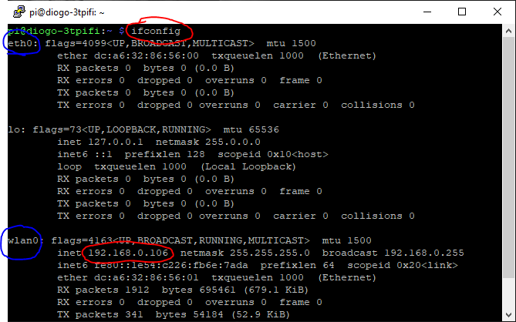

29. Then write “sudo route -n” (without quotes “”) to check your Gateway: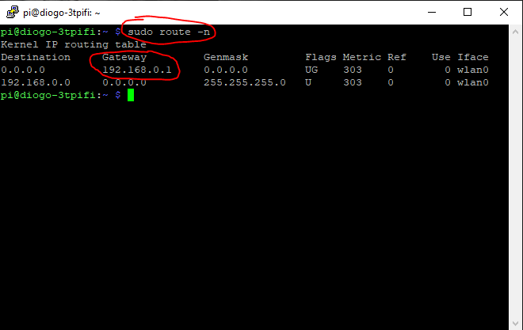

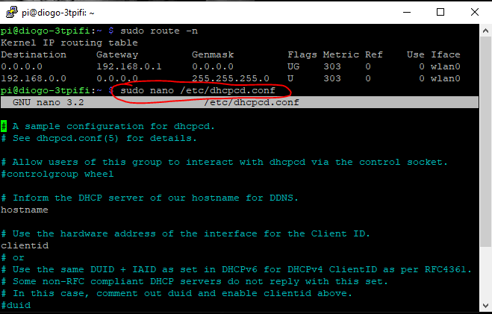30. Then write “sudo nano /etc/dhcpcd.conf” (without quotes “”) to start changing your ip address to a static one:

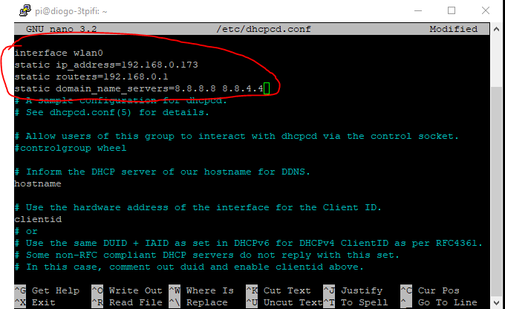31. Then u will write the following commands:

-In “interface” you put wlan0 if you are using Wi-Fi or eth0 if you are using ethernet cable.

-In “static ip_address=” you put the ip that you want as a static ip.

-In “static routers=” you put your Gateway.

-In “static domain_name_servers=” you just put “8.8.8.8 8.8.4.4” as is written there.

32. After you finish writing that just press Ctrl+X and then Y to save, then press enter, and write “sudo reboot” (without quotes “”) to reboot your RaspberryPi:

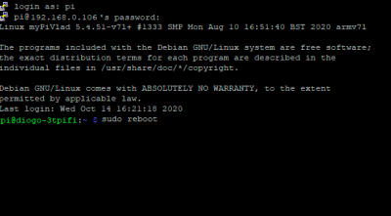

33. After you rebooted your RaspberryPi, you will need VNC Viewer:

<https://www.realvnc.com/en/connect/download/viewer/>

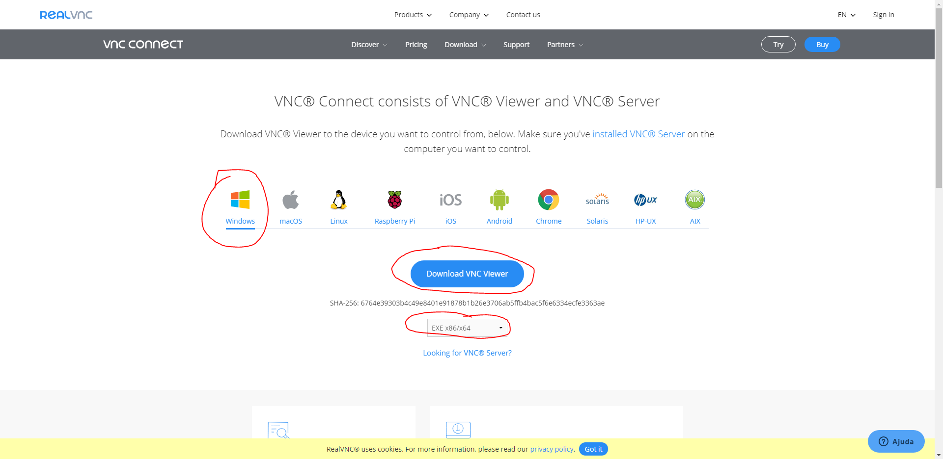34. When installing VNC Viewer just press next until its installed: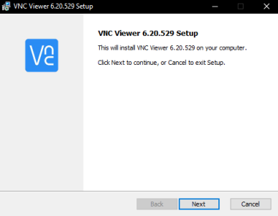

35. Open VNC Viewer and write your new ip:

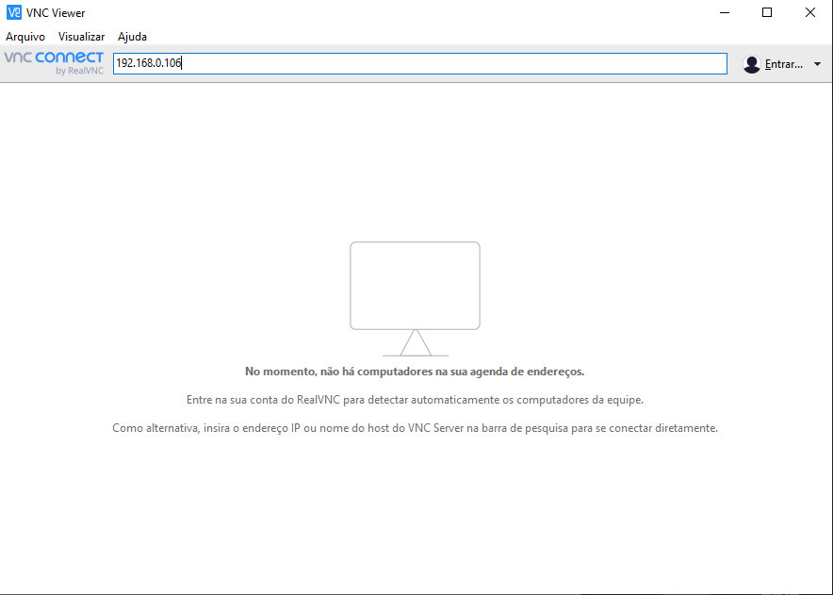

36. Press enter and wait until it opens a new window and write “pi” as username and the password that you wrote before:

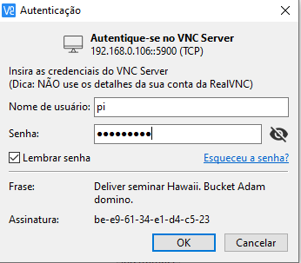

37. Press enter and wait until it opens a new window and that’s it:

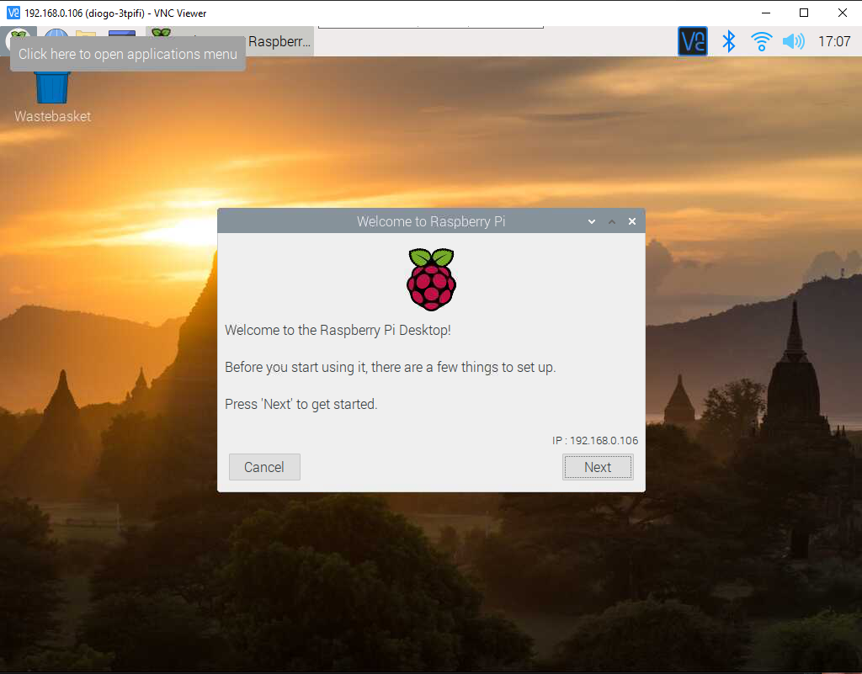

38. Then open “Thonny Python IDE” and write this to print 10 times “Hello”:

